1. Discuss different selector forms that can be used to apply style information for HTML elements.

2. Write the HTML code to generate the following output.

* + - * + The background image paper.gif is repeated
        + The background image tree.gif is not repeated



**HELLOO**

3. Why are javaScript scripts sometimes hidden in HTML documents by putting them into HTML comments?

4. Describe the two ways the properties of an object can be referenced.

5. Answer the following questions based on HTML :

(a) Explain the use of HTML tag to embed an audio clip in HTML file. (2 maRKS)

(b) Write the HTML code to generate a Web Page in the format given below: (10 Marks)

(Use external CSS for style specifications)

Consider the following while writing the HTML code :

1. Title of the page should be ‘‘Media in life’’.

2. Background of the page is ‘‘pink’’, Link colour should be ‘‘blue’’.

3. Heading of the page is ‘‘maroon’’.

4. Picture used in the page is the file ‘‘images.jpeg’’.

5. Text in paragraph is ‘‘red’’.

6. Table should have a border of width 1, border of the table should be ‘‘green’’.

7.Pages linked to :

* Evolution as ‘‘evol.html’’
* References as ‘‘ref.html’’

8. Bottom message is of size 2 and mail is linked to [contact@abc.com](mailto:contact@abc.com).

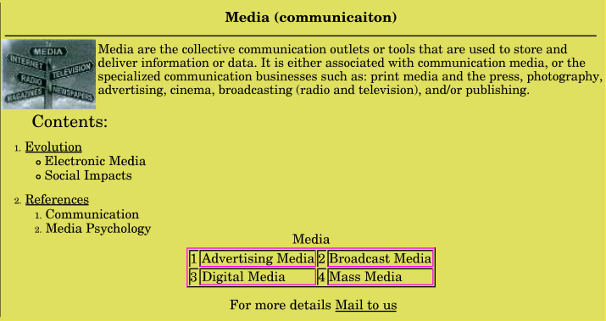

6.a) what are the five primitive data types in JavaScript? (4 marks)

b) Write HTML and JavaScript code to compute the real roots of a quadratic equation. The JavaScript Script gets the coefficients of the quadratic equation from the user with prompt and computes and displays the real roots of the given equation. (8 Marks)